**GitHubAssignment**



**CS361**

**Christopher Bernal**

**Part 3**

What is GitHub? When was it created? Why? By who? What similar platforms exist? Why would you use such a platform?

GitHub is a Git repository hosting service who offers all distributed version control and source management functionality of Git as well as implementing its own features. GitHub was created by Tom Preston-Werner, Chris Wanstrath, and Pj Hyett on February 2008 Some similar platforms to GitHub would have to be BitBucket, SourceForge, Gogs, Launchpad, and Trac. I would use such platform to upload my code for it to be seen and edited.

**Part 4**

Go through the Git tutorial here: <https://try.github.io>. While doing the tutorial, save your work the *LastnameFirstnameGitTutorial-mm-dd-yyyy.docx* file.

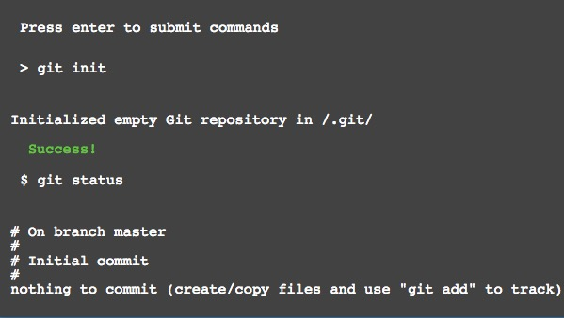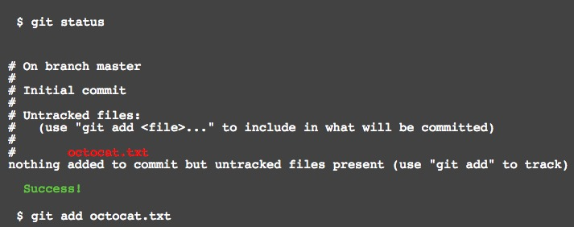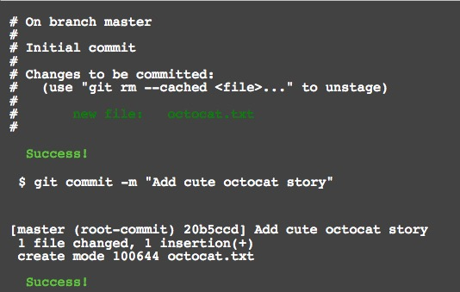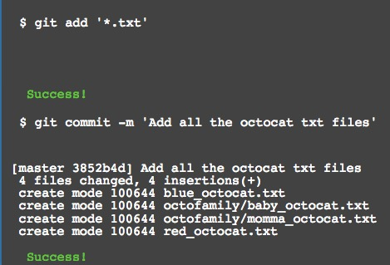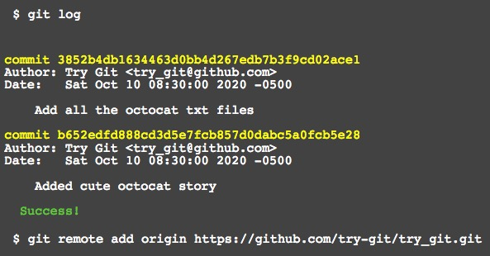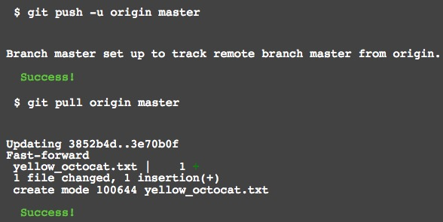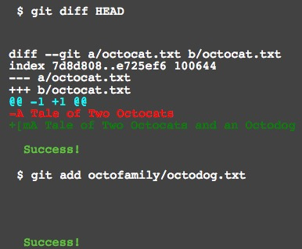 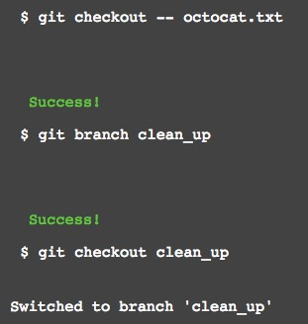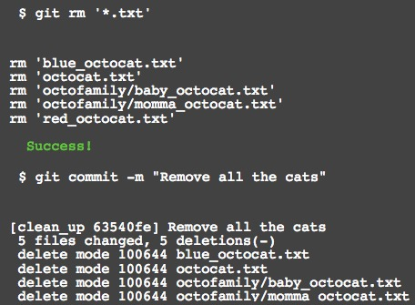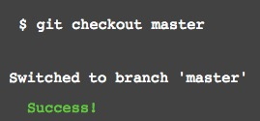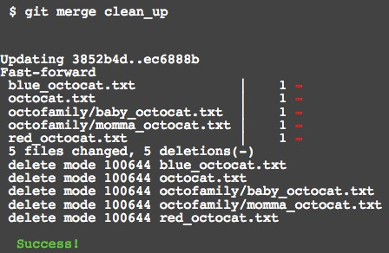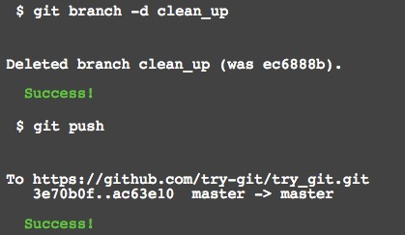

**Part 5:**

Define the following terms in the context of Git (2 lines maximum):

* Repository
* Commit
* Push
* Branch
* Fork
* Merge
* Clone
* Pull
* Pull request

**Repository** - a directory where git has been initialized to start version controlling your files

**Commit** - takes all the file contents that have been staged with git add and records a new permanent snapshot in the database and then moves the branch pointer on the current branch up to it

**Push**- command is used to communicate with another repository, calculate what your local database has that the remote one does not, and then pushes the difference into the other repository.

**Branch-** can list the branches you have, create a new branch, delete branches and rename branches.

**Fork-**will make a copy of the project that is entirely yours; it lives in your user’s namespace, and you can push to it.

**Merge-** tool is used to merge one or more branches into the branch you have checked out. It will then advance the current branch to the result of the merge.

**Clone**- creates a new directory, goes into it and runs git init to make it an empty Git repository, adds a remote (git remote add) to the URL that you pass it (by default named origin), runs a git fetch from that remote repository and then checks out the latest commit into your working directory with git checkout.

**Pull -** command is basically a combination of the git fetch and git merge commands, where Git will fetch from the remote you specify and then immediately try to merge it into the branch you’re on.

**Pull request- c**ommand is simply used to generate an example message body to email to someone.

**Part 7:**

Retrieve the README.md file at:

<https://github.com/paceuniversity/courses>

Add your name (lastname, firstname) in the file, **add a comment (date and time) (REQUIRED)**, and update the README.md file at: <https://github.com/paceuniversity/courses>. Your name should appear at the provided <https://github.com/paceuniversity/courses>. Please check the work of previous students.

List the commands and strategy you use to do this part of the exercise in the *LastnameFirstnameGitTutorial-mm-dd-yyyy.docx* file and push it to: <https://github.com/yourpseudo/CSXXX2016>.

**Step By Step**

I went on the Github account <https://github.com/paceuniversity/courses>

Then I located the README.md file and I created a fork so that I would be able to have my own version where I would commit my changes to the file.

Once I had finished making changes I sent a pull request

Finally I just waited for the pull.